TODO REST API Application

Description
- This is a TODO REST API Application that uses NodeJS, Express and JavaScript with JWT Middleware Authentication.

Prerequisites
- Used NodeJS (v14.x)
- Git
- MongoDB
- Postman (For testing of API Endpoints)
- Visual Studio Code (For coding IDE)
- MongoDB Atlas (For Setup of database)

Installation
- Clone the project.
- Execute npm i/npm install to get the “node modules” folder.

Deployment
- Local deployment - npm run start

Contents of the TODO Rest API Application
- src
  - api-routes.js
- Contains processes of routing (refers to application’s endpoints (URI) respond to client request), defines your app routes (endpoints)
  - controller
- Contains all the connection between the API routes and services functions
  - services
- Contains all business logic methods, get the request from the routes and convert to HTTP responses
  - data
- Data models required for the application, also depend on the datastore used which are: ORM (Object Relational Mapping) library (use case for a relational database) and a non-relation (NoSQL) database.
  - configs.json
- Contains configurable in JSON format (e.g. PORT, DB_CONN)
  - index.js
- Node app file to start a server
  - package.json
- versioning file used to install multiple packages
  - package-lock.json
- created for locking the dependencies with the installed version

TODO Rest API Flow
- Create User
- Generate Token credentials and use it for API calls (username, password)
- Create Task
- Show all Tasks
- Retrieve Task using its unique id
- Update a Task (Status/Name)
- Delete a Task
- Delete All Completed Tasks

Execution of Unit Tests
Users (command: jest test/user.test.js)
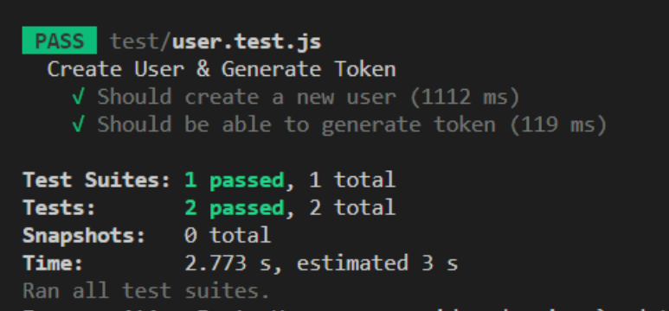

TODOs (command: jest test/task.test.js)
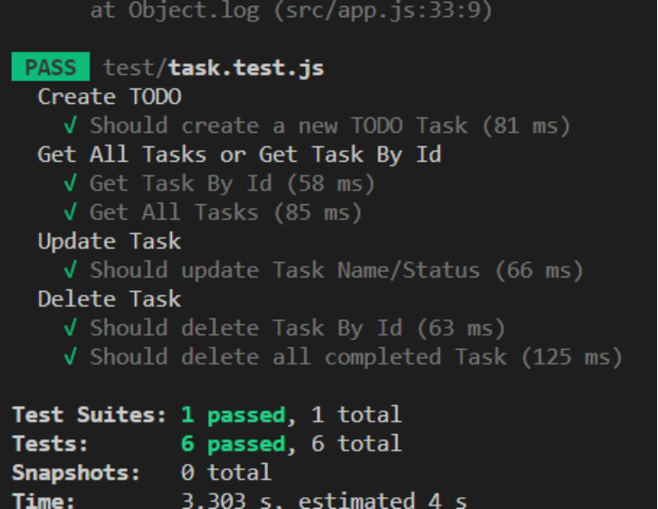
APIs/Endpoints with sample Request and Response

Users
- Create User
POST - /api/users/ Request Body: {"uname":"user8","password":"1234"}

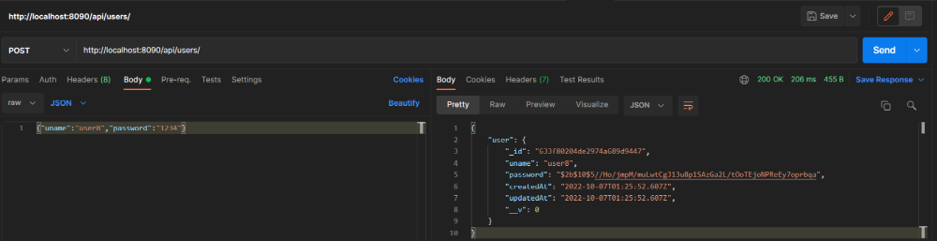

- Generate Token (valid for 1 hr)
POST - /api/auth/ Request Body: {"uname":"user8","password":"1234"}
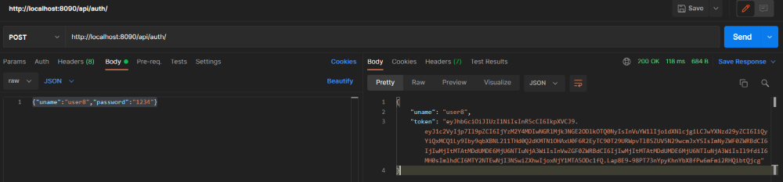

TODOs
- Create Task
POST - /api/tasks/ Request Body: {"task": "this is a task"}
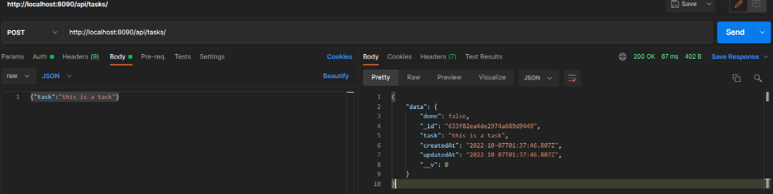

- Retrieve Task using its unique id
GET - /api/tasks/633f1c338fbc804770940757
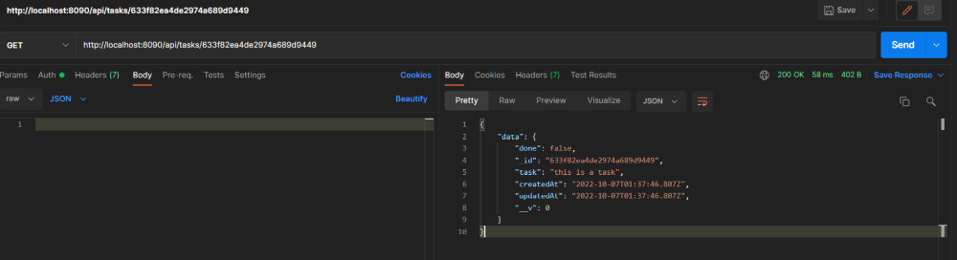

- Update Task using its unique id
PATCH - /api/tasks/633f1c338fbc804770940757
Request Body: {"task": "Updates a Status", “done”:true}
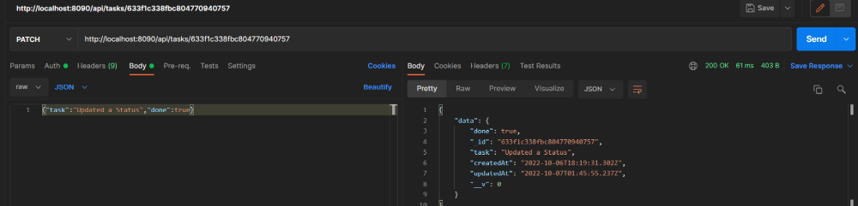

- Delete Task using its unique id
DELETE - /api/tasks/633f1c338fbc804770940757
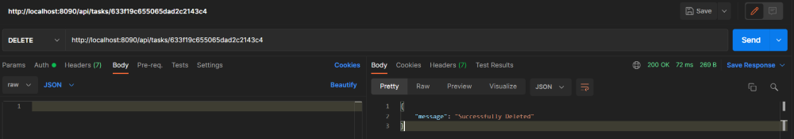

- Delete All Completed Task
DELETE - /api/tasks/
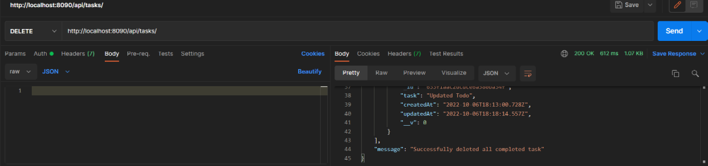

Notes

- Github repository: https://github.com/nico080/todo-backend-api-2022 May try Live version:
https://todo-backend-api-2022.nicoagb.repl.co/api/{endpoint} -https://replit.com/@nicoagb/todo-backend-api-2022

DIAGRAM

